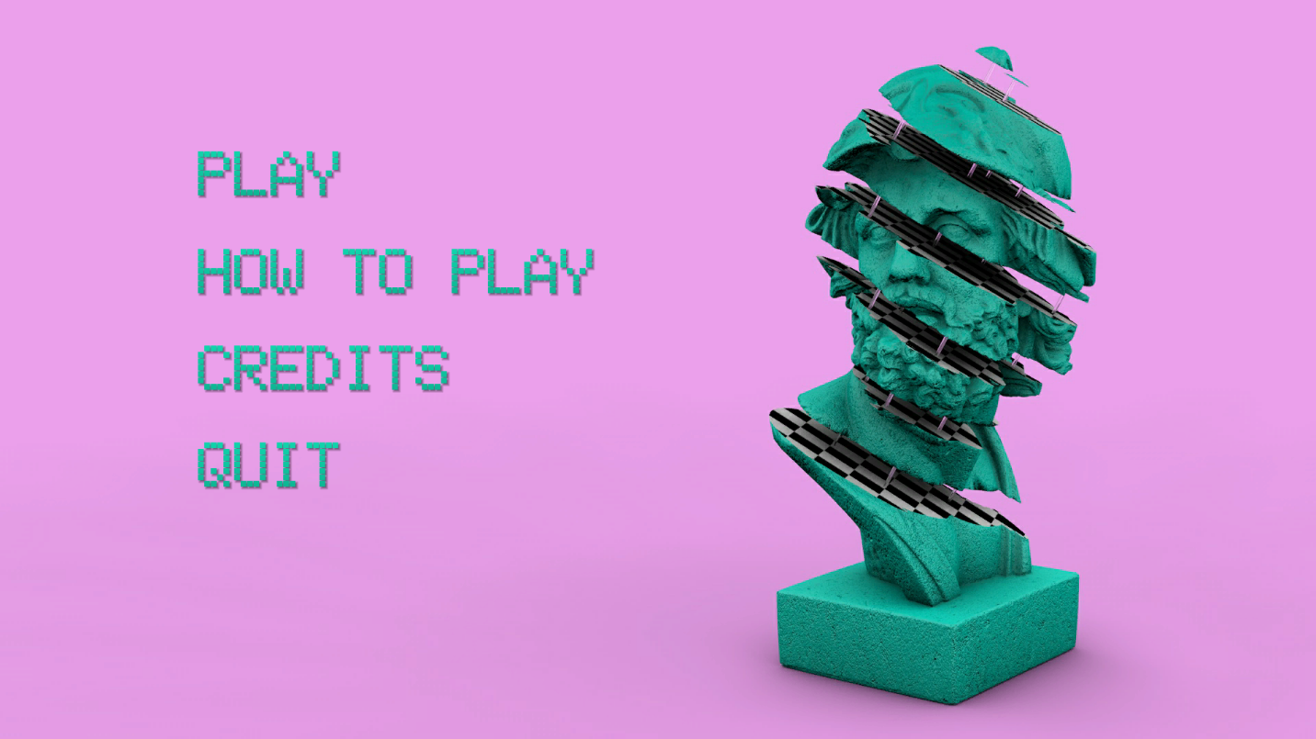

**“Relax”**

**Game Design Document**

**Table of Contents**

|  |  |  |
| --- | --- | --- |
| [1 Game Overview](https://n-xovwktmtjsnaxyc2mwes2xu7pohqedmdm6zjw5q-2lu-script.googleusercontent.com/userCodeAppPanel)  [2 High Concept](https://n-xovwktmtjsnaxyc2mwes2xu7pohqedmdm6zjw5q-2lu-script.googleusercontent.com/userCodeAppPanel)  [3 Synopsis](https://n-xovwktmtjsnaxyc2mwes2xu7pohqedmdm6zjw5q-2lu-script.googleusercontent.com/userCodeAppPanel)  [4 Game Objectives](https://n-xovwktmtjsnaxyc2mwes2xu7pohqedmdm6zjw5q-2lu-script.googleusercontent.com/userCodeAppPanel)  [5 Game Rules](https://n-xovwktmtjsnaxyc2mwes2xu7pohqedmdm6zjw5q-2lu-script.googleusercontent.com/userCodeAppPanel)  [6 Game Play](https://n-xovwktmtjsnaxyc2mwes2xu7pohqedmdm6zjw5q-2lu-script.googleusercontent.com/userCodeAppPanel)  [6.1 Game Controls](https://n-xovwktmtjsnaxyc2mwes2xu7pohqedmdm6zjw5q-2lu-script.googleusercontent.com/userCodeAppPanel) (PC)  [6.2 HUD](https://n-xovwktmtjsnaxyc2mwes2xu7pohqedmdm6zjw5q-2lu-script.googleusercontent.com/userCodeAppPanel)  [7 Players](https://n-xovwktmtjsnaxyc2mwes2xu7pohqedmdm6zjw5q-2lu-script.googleusercontent.com/userCodeAppPanel)  [7.1 Characters](https://n-xovwktmtjsnaxyc2mwes2xu7pohqedmdm6zjw5q-2lu-script.googleusercontent.com/userCodeAppPanel)  [8 Art](https://n-xovwktmtjsnaxyc2mwes2xu7pohqedmdm6zjw5q-2lu-script.googleusercontent.com/userCodeAppPanel)  [8.1 Setting](https://n-xovwktmtjsnaxyc2mwes2xu7pohqedmdm6zjw5q-2lu-script.googleusercontent.com/userCodeAppPanel)  [8.2 Level Design](https://n-xovwktmtjsnaxyc2mwes2xu7pohqedmdm6zjw5q-2lu-script.googleusercontent.com/userCodeAppPanel)  [8.3 Audio](https://n-xovwktmtjsnaxyc2mwes2xu7pohqedmdm6zjw5q-2lu-script.googleusercontent.com/userCodeAppPanel)  9 What you Developed  10 Credits  11 Development Log   |  | | --- | |  | | **GAME DEVELOPMENT**  **TEAM MEMBERS**    PRODUCER  AC De Leon    PRODUCTION MANAGER  AC De Leon    PRODUCTION COORDINATOR  AC De Leon  GAME DESIGNERS  AC De Leon  SYSTEMS/IT COORDINATOR  AC De Leon  PROGRAMMERS  AC De Leon  TECHNICAL ARTISTS  AC De Leon  AUDIO ENGINEERS  AC De Leon  UX TESTERS  AC De Leon |

|  |
| --- |
|  |

# 1 Game Overview

**Title:** *Relax*

**Platform:** PC Standalone

**Genre:** Exploration

**Rating:** (10+) ESRB

**Target:** Casual gamer (aging from 12 - 30)

**Release date:** February 2018

**Publisher:** acfromspace

*Relax* is a game where you explore the wonders of procedural generation.

# 2 High Concept

*Relax* is to be set in a galaxy of ancient wonders where the player simply explores what the galaxy has to offer. There is no winning or losing, there is simply exploring.

# 3 Synopsis

You are a being in a galaxy filled with vaporwave.

# 4 Game Objectives

The objective of the game is to explore and relax. A getaway from the real world.

# 5 Game Rules

There are no game rules. The player sets off in any direction to explore what the galaxy offers. If the player is found stuck, simply pause the menu and restart.

# 6 Game Play

## Game Controls (PC)

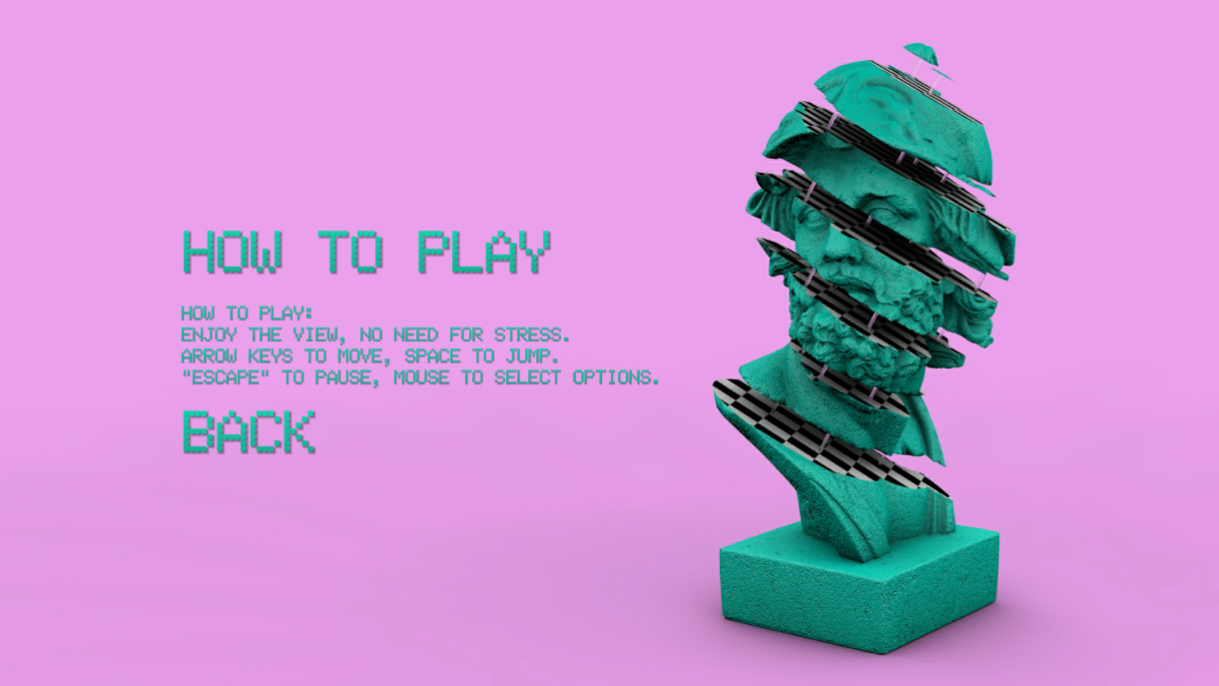

## HUD

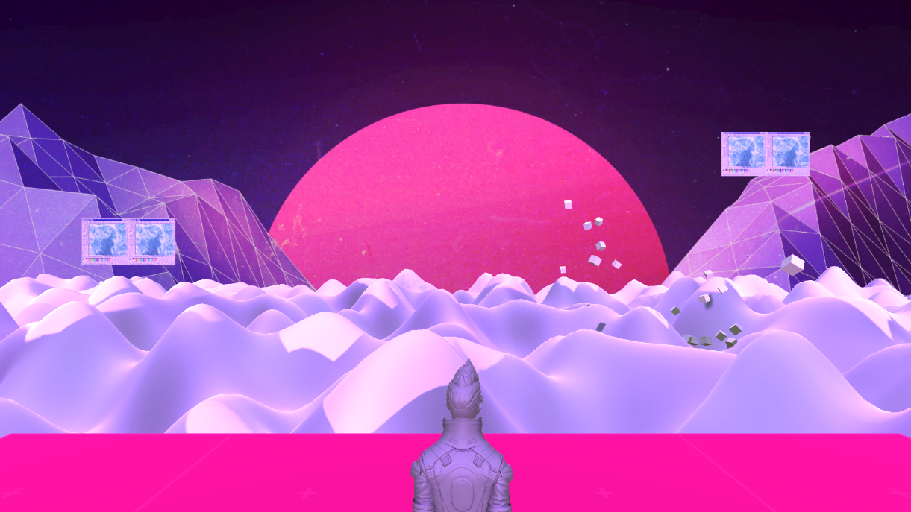

# 7 Players

## Characters

The Player is a being of gray matter. Looking to fill his heart with color and meaning.

# 8 Art

## Setting

The game takes place above the clouds, over the horizon.

## Level Design

The level consists of a single plane and a procedurally generated terrain that travels in real time. The terrain is to mimic clouds.

## Audio

|  |  |  |
| --- | --- | --- |
| Name | Category | Description |
| Macintosh Plus – Computing Lisa Frank 420 / Modern.mp3 | Game Music | Plays during gameplay |

# 9 What you Developed

The aesthetic of the game, coding the entirety of it.

# 10 Credits

Macintosh – Song

Unity – Standard Assets

# 11 Development Log

2018/02/01

Initial commit.

2018/02/01

Project Init.

2018/02/09

Procedural Grid Init.

2018/02/10

Procedural Grid complete, work on playable level.

2018/02/10

Another example of procedural generation, terrain style.

2018/02/10

Rigid body capsule works w/ terrain

2018/02/10

Unity Standard Assets for controller.

2018/02/11

Main menu, music added.

2018/02/11

Polishing, pause menu needs refining

2018/02/11

Future development:

* A larger world for exploring, cloud level, water level, any types beneficial for world building.
* The ability to shapeshift into certain objects to traverse the lands.
* More lo-fi/vaporwave songs.